1.. Retrieve the total number of orders placed
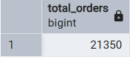

2. Calculate the total revenue generated from the pizza sales
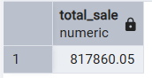

3.Identify the highest-price pizza
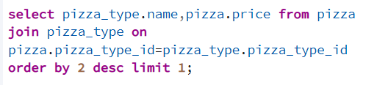
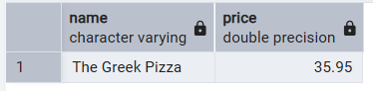

4.Identify the most common pizza size order
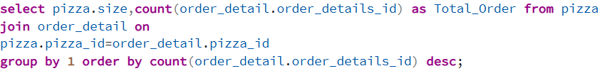
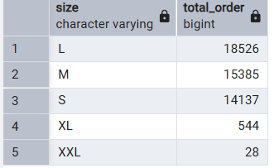

5 list the top most ordered pizza type along with their quantity
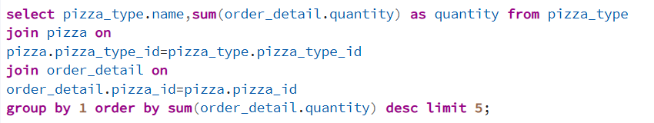
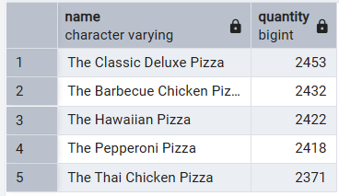

6.Find the Total quantity of each pizza category ordered
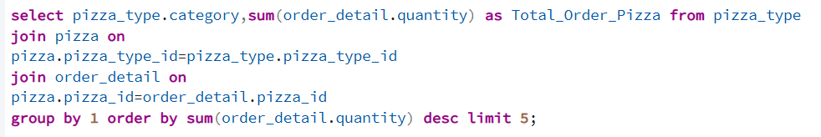
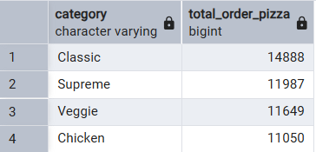

7. Determine the distribution of orders by hour of the day
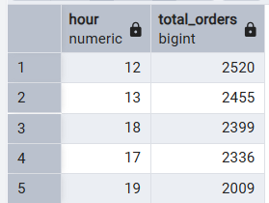

8.Find the category wise distribution
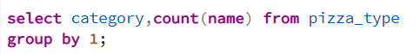
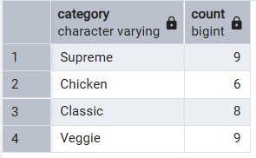

9. Group the order by date and calculate the avg number of pizza ordered per day
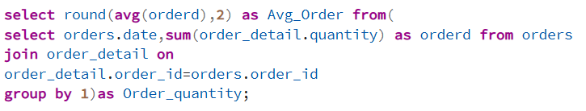
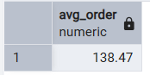

10. Determine the top 3 most ordered pizza type based on revenue
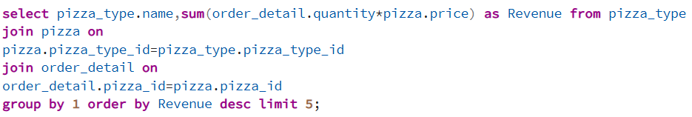
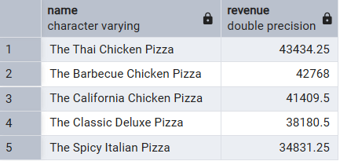

11.Calculate the % contribution of each pizza type of total revenue

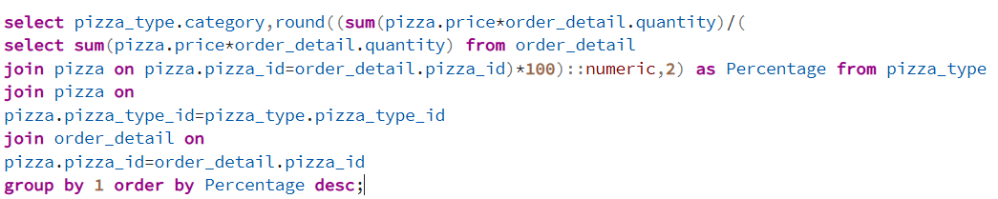
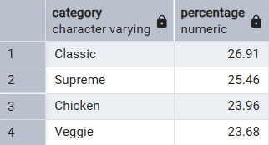

12.Analysis the cumulative revenue generated over time
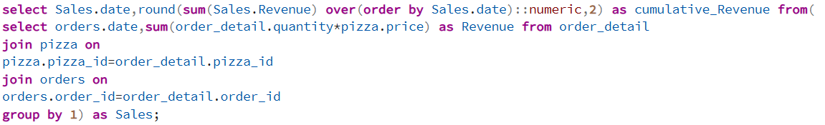
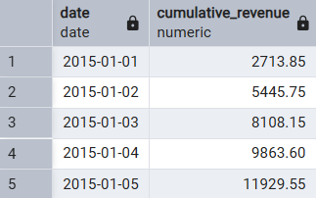

13.Determine the top 3 most ordered pizza type based on revenue for each pizza category
